**GitHub:** [**https://github.com/jeremyloa/qualif-flutter-jm22-1**](https://github.com/jeremyloa/qualif-flutter-jm22-1)

1. **Login page**

* Logo, fields, button

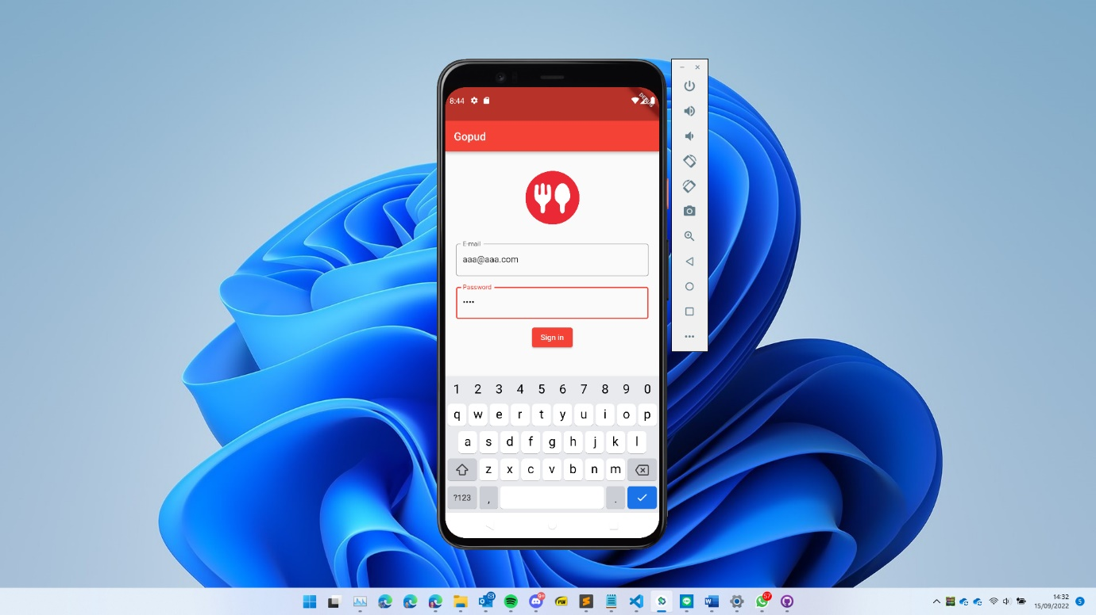

* Empty validation

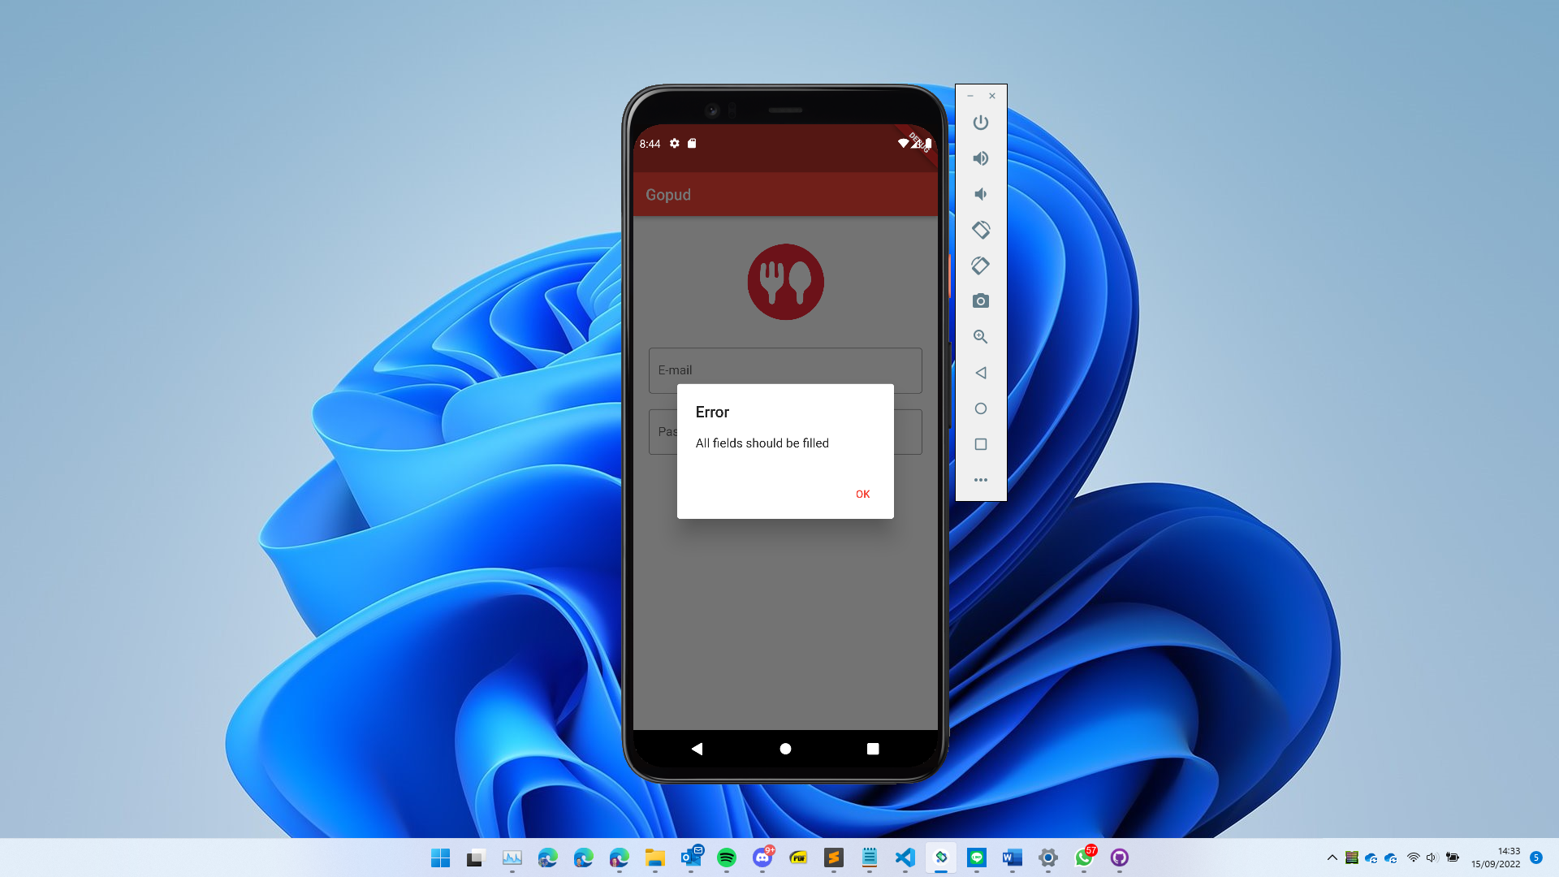

* Email contains ‘@’

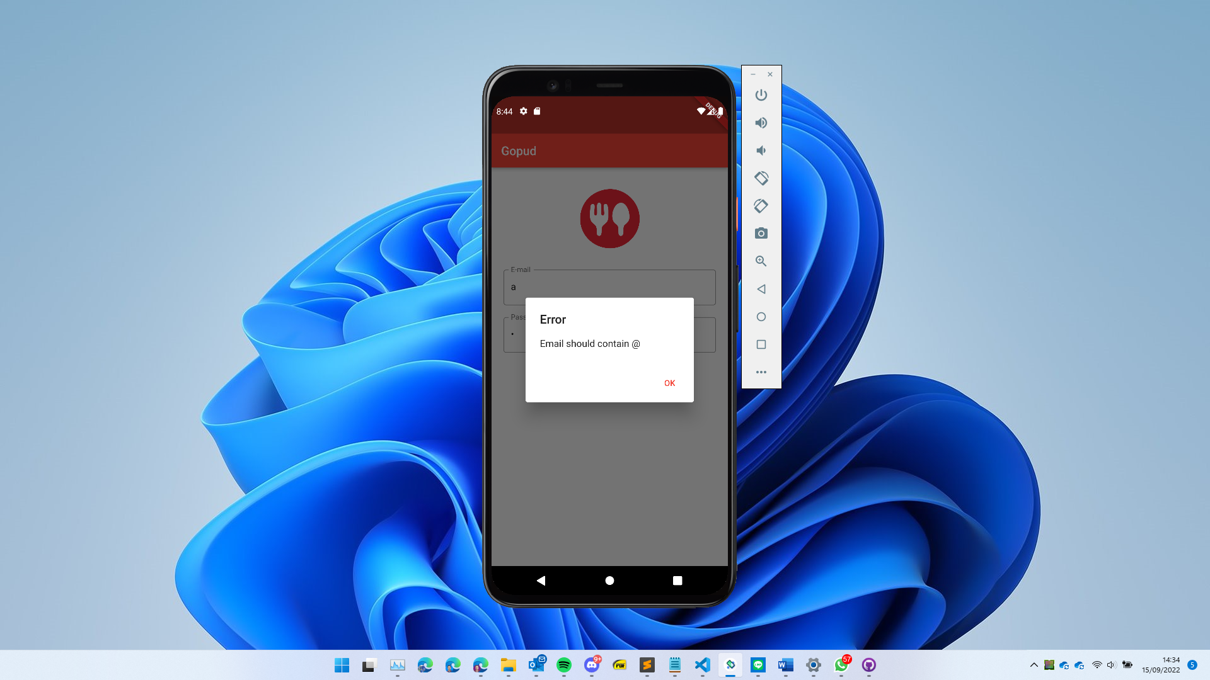

* Email ends with ‘.com’

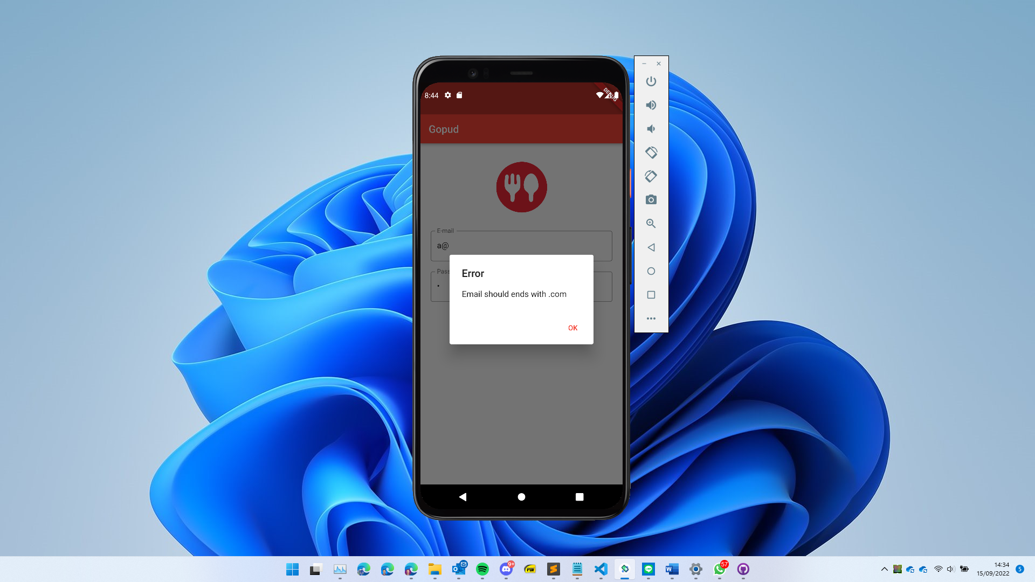

* Password length >= 6

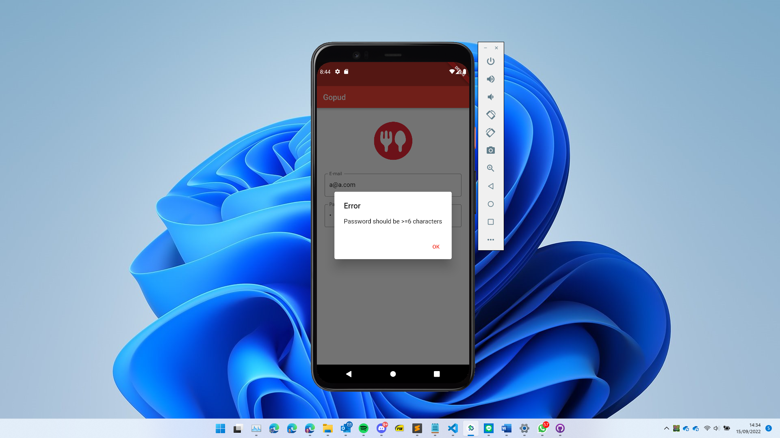

1. **Home page**

* Carousel, infographics

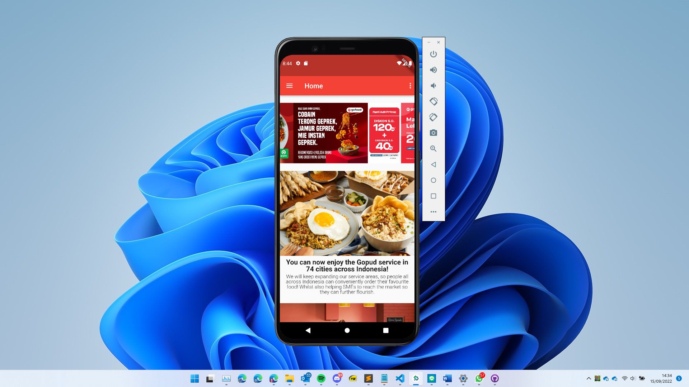

* Toggle light/dark mode

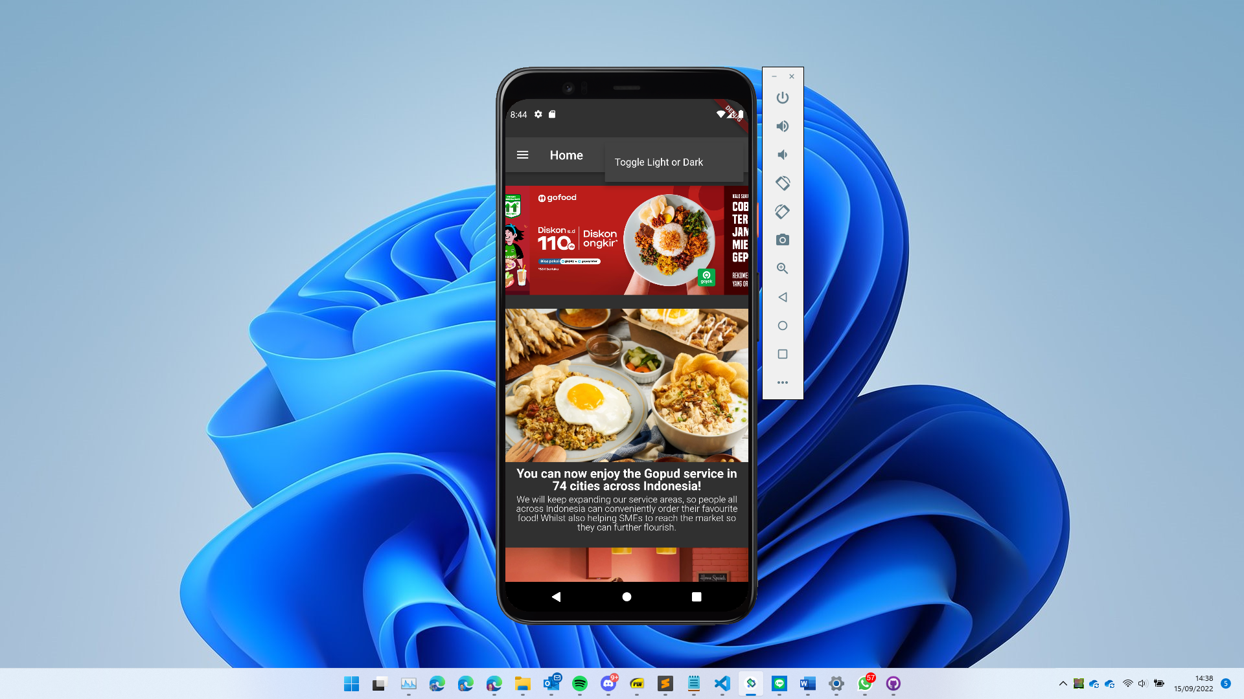

* Navigation bar

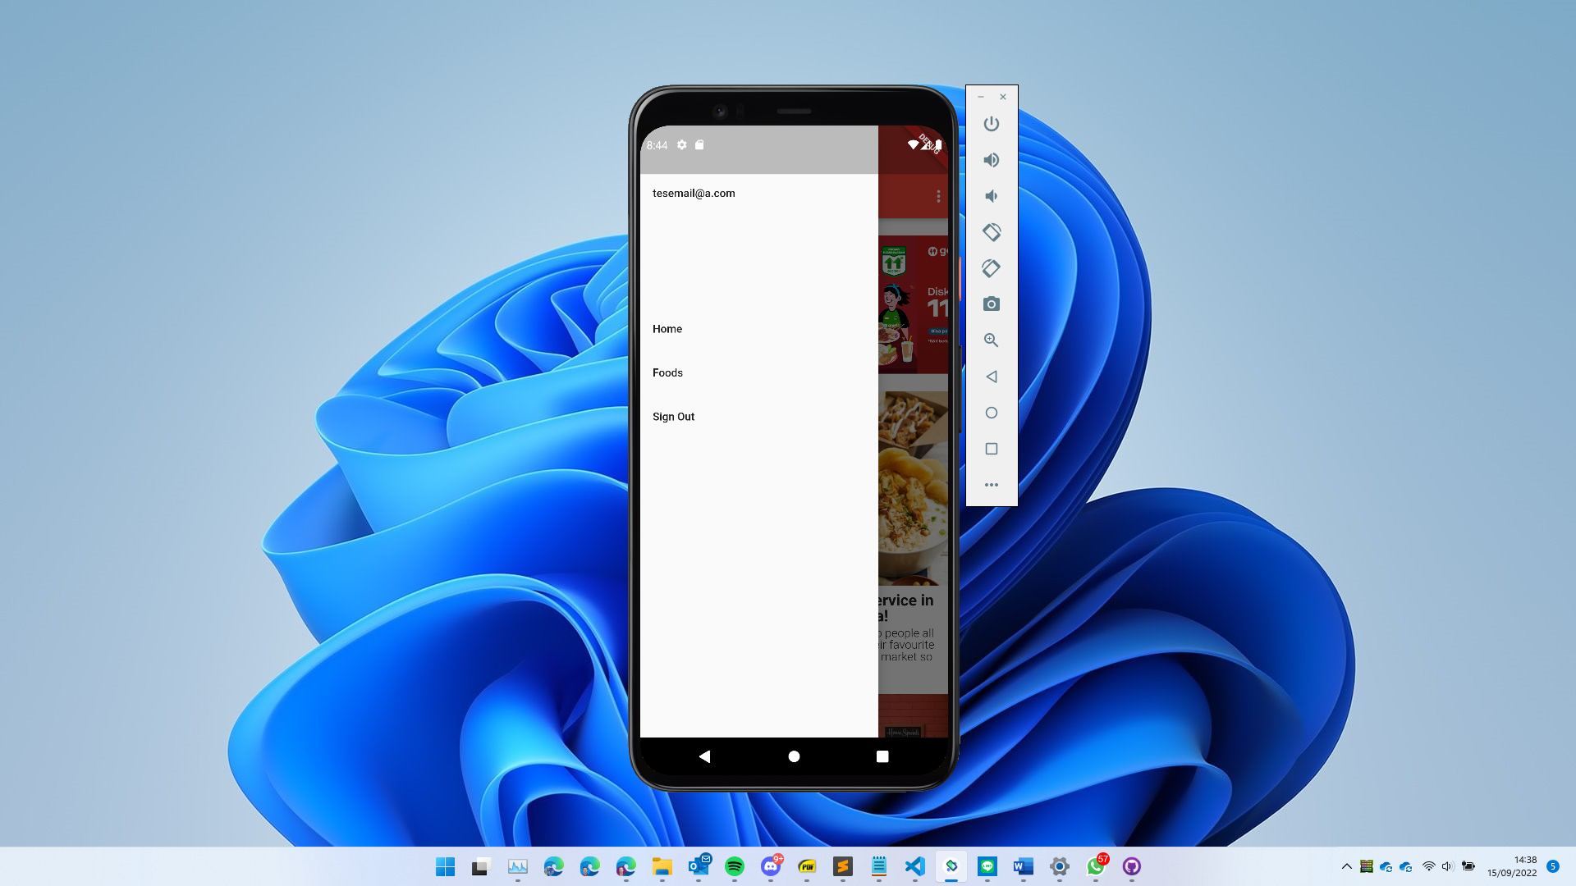

1. **Items page**

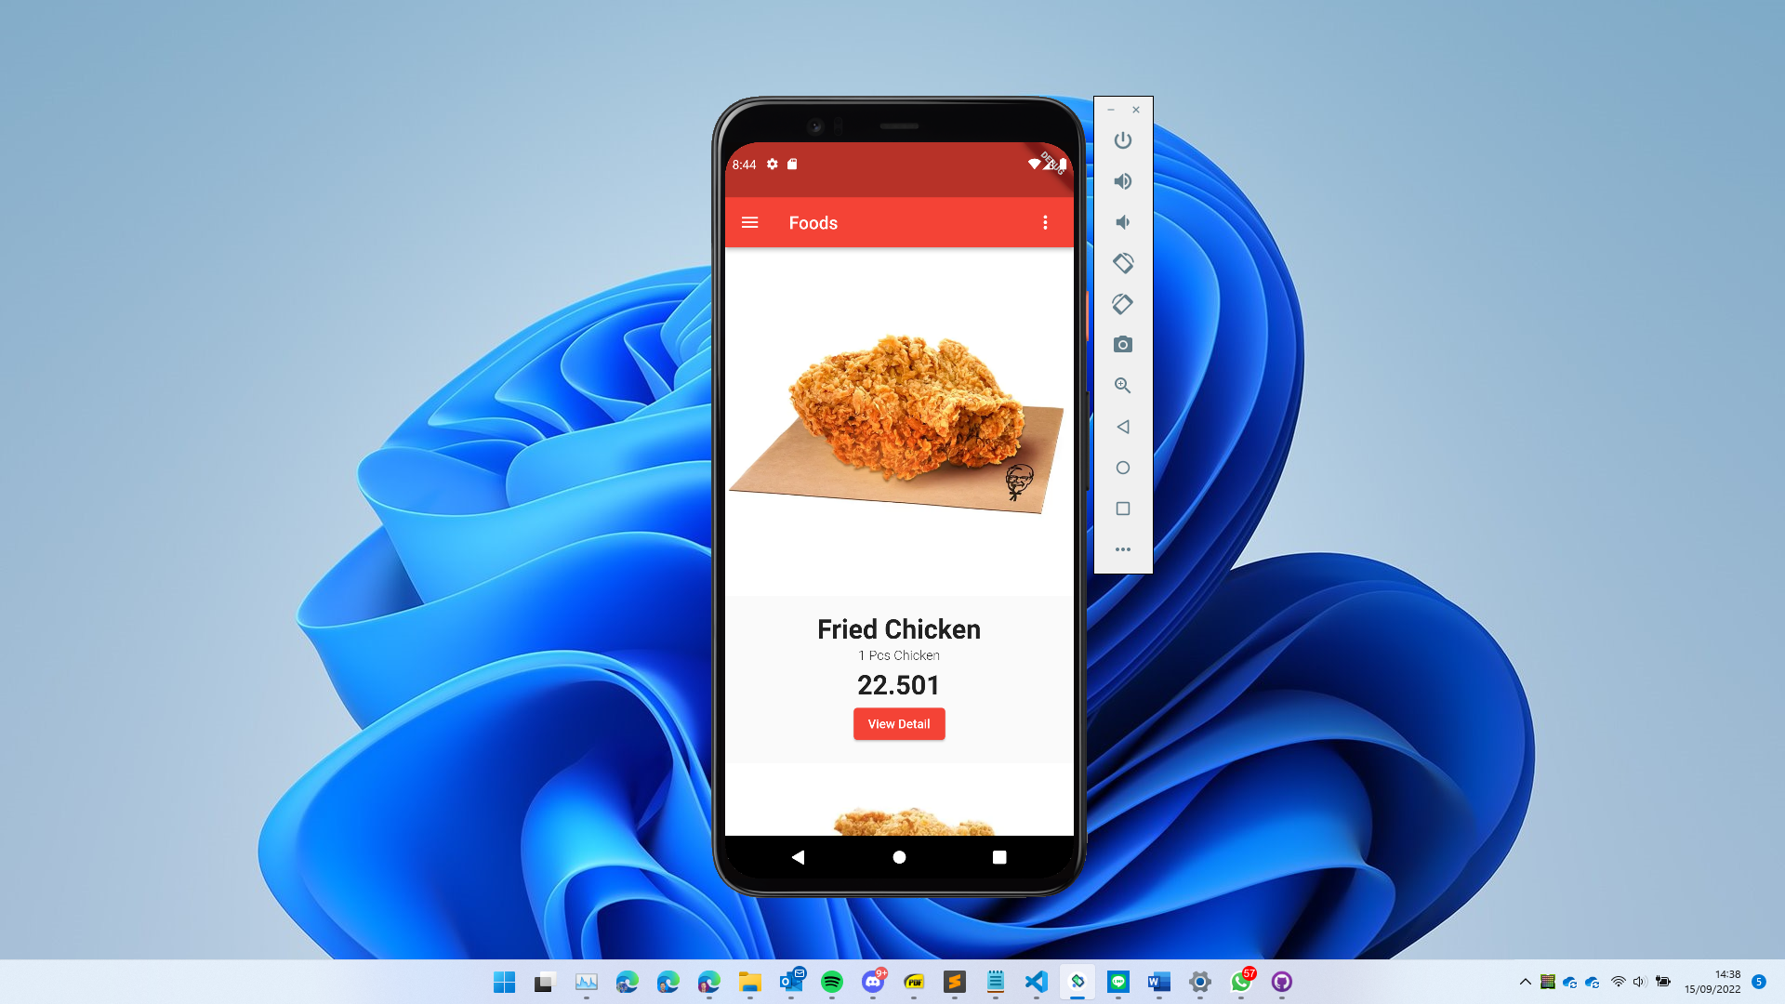

1. **Details page**
2. Product page

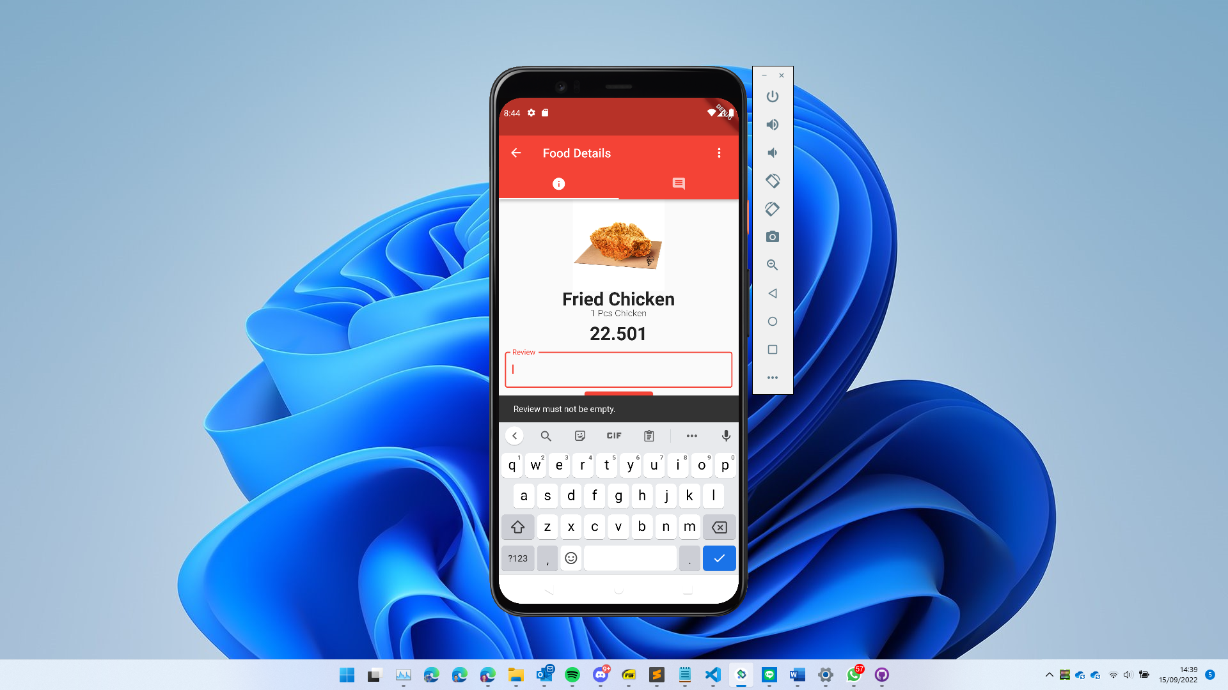

1. Comments page

